Q1ap1

Q1bp1

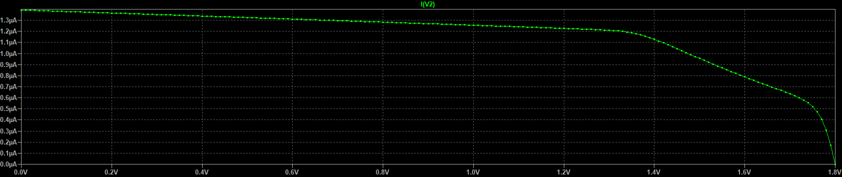

Q1ap2

Q1bp2

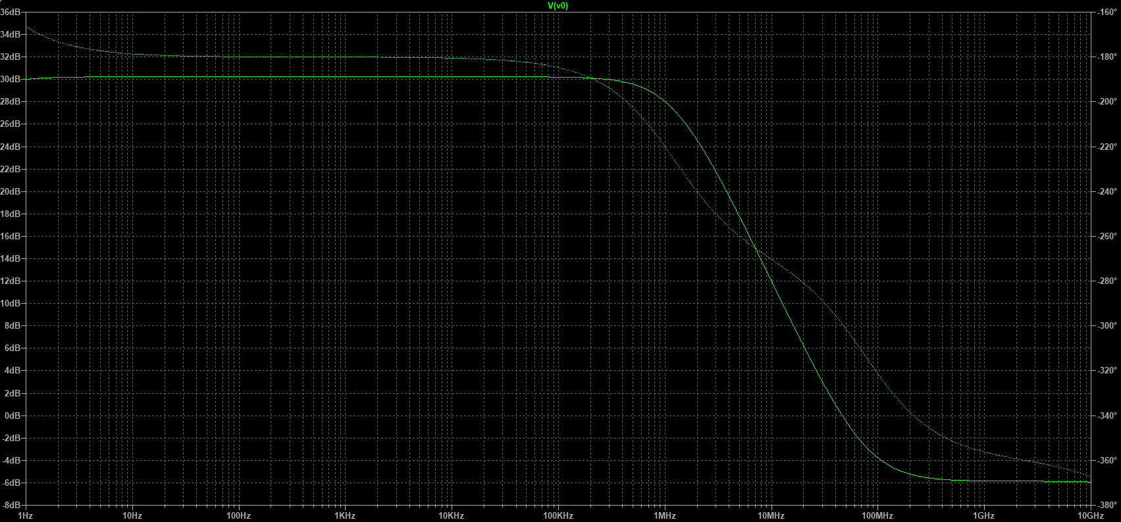

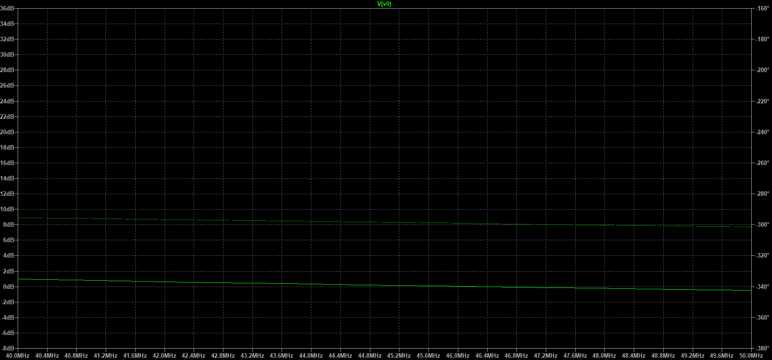

Noise Simulation:

